Version 0.0
september 19, 2017



Release Notes
APPLY BILLABLE EVENT
FOR IMPORT FULL CONTAINER

Prepared for



Punta Caucedo, Boca Chica 15700, Dominican Republic

Table of Contents
1. Apply Billable Event for Import Full Container 3
2. Client Requirement 3
3. Scope 3
4. Configuration: 4
4.1. Add Event Type 4
4.2. Add Groovy Plugin: 5
4.3. ADD Groovy Job 6
4.4. Add General Reference 7
4.5. Groovy Code 8
5. Test Cases: 10
6. Screengrabs: 14

Apply Billable Event for Import Full Container
Enhancement to record the specified Billable Event against an Import full container by scheduling the Groovy Jobs

Client Requirement
- The groovy job only run one time by day at 20:00 every day
- When found all Import full containers in yard that are in a specific zone in yard
- Only apply the billable event for container that are in the verification zone with the different group code Apply “DC, FL, VS, VH, CVD, RS, ZR.

Scope
Create Event Type | : | NSWVERIF
Create General Reference | : | DPWCAUYARDBLK
Create Groovy Job | : | BILLABLEEVENTFORVERIFICATIONZONE
Create Groovy Plugin | : | DpwCauGvyBillableEvntForVerificationZone

Configuration:

Add Event Type
Location: Configuration→Services→Event Types

Create new event using data as shown below

Id : NSWVERIF
Applies To : Unit
Billble : Yes
Notifiable : Yes
Can be Bulk-Applied : Yes
Auto-Extract : Yes

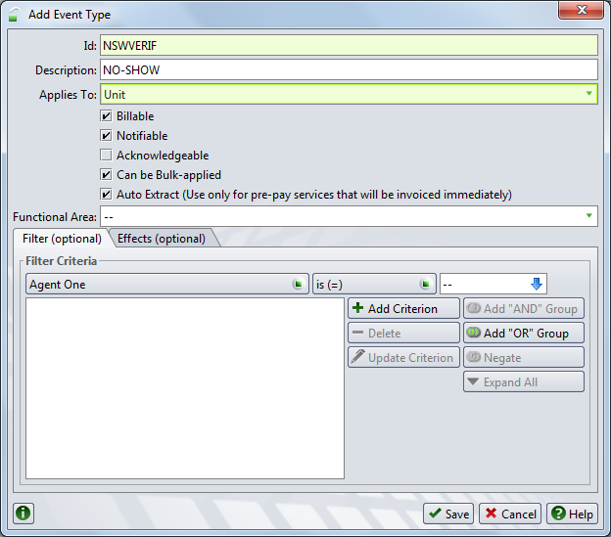

Add Groovy Plugin:
Location: Administration →System →Groovy Plug-ins

Short Description : DpwCauGvyBillableEvntForVerificationZone

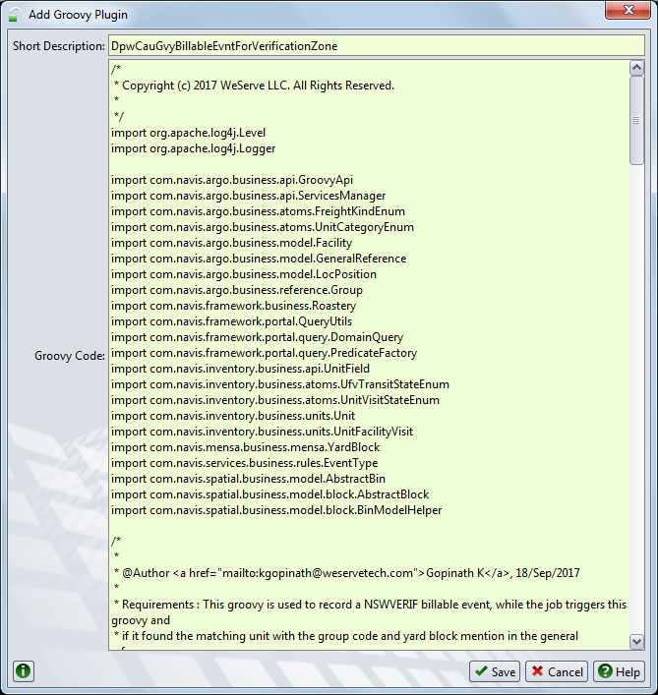

ADD Groovy Job
Location: Administration →System →Groovy Jobs

ID : BILLABLEEVENTFORVERIFICATIONZONE
Description : PREADVISE
Job Execution Group : Background Jobs
Included : DpwCauGvyBillableEvntForVerificationZone

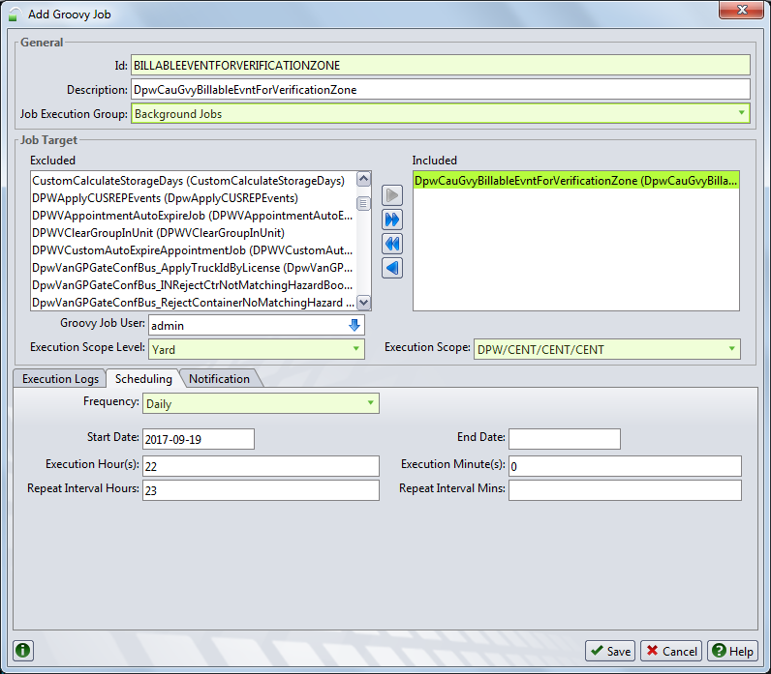

Add General Reference
Location: Configuration →Other →General Reference

Configure the General Reference as below:

Type : DPWCAUYARDBLK (Should be same as specified)
Identifier 1 : YARDBLOCK (Should be same as specified)
Identifier 2 : GRPCODE (Should be same as specified)
Identifier 3 : EVENTID (Should be same as specified)
Data Value 1 : AW (Yard Block)
Data Value 2 : Y (Yard Block)
Data Value 3 : DC,FL,VS,VH,CVD,RS,ZR (Group Code)

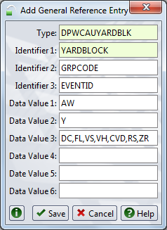

Groovy Code

DpwCauGvyBillableEvntForVerificationZone.groovy

/*
* Copyright (c) 2017 WeServe LLC. All Rights Reserved.
*
*/
import org.apache.log4j.Level
import org.apache.log4j.Logger

import com.navis.argo.business.api.GroovyApi
import com.navis.argo.business.api.ServicesManager
import com.navis.argo.business.atoms.FreightKindEnum
import com.navis.argo.business.atoms.UnitCategoryEnum
import com.navis.argo.business.model.GeneralReference
import com.navis.argo.business.reference.Group
import com.navis.framework.business.Roastery
import com.navis.framework.portal.QueryUtils
import com.navis.framework.portal.query.DomainQuery
import com.navis.framework.portal.query.PredicateFactory
import com.navis.inventory.business.api.UnitField
import com.navis.inventory.business.atoms.UfvTransitStateEnum
import com.navis.inventory.business.atoms.UnitVisitStateEnum
import com.navis.inventory.business.units.Unit
import com.navis.inventory.business.units.UnitFacilityVisit
import com.navis.services.business.rules.EventType

/*
*
* @Author <a href="mailto:kgopinath@weservetech.com">Gopinath K</a>, 18/Sep/2017
*
* Requirements : This groovy is used to record a NSWVERIF billable event, while the job triggers this groovy and
* if it found the matching unit with the group code and yard block mention in the general reference.
*
* @Inclusion Location : Incorporated as a groovy plugin extending GroovyApi as mention below:
*
* Deployment Steps:
* a) Administration -> System -> Groovy Plugins
* b) Click on + (Add) Button
* c) Add as groovy code - DpwCauGvyBillableEvntForVerificationZone
* d) Paste the groovy code and click on save
*
* @ Set up the groovy job to be scheduled for an hour 22:00 to call this groovy.
*
* @ Set up General Reference of Type as "DPWCAUYARDBLK" and Identifier1 as "YARDBLOCK",Identifier2 as "GRPCODE",Identifier3 as "EVENTID" and value with list of yardblock in value 1 and value2, list of group code in value3 and event id in value 4.
*
*/
class DpwCauGvyBillableEvntForVerificationZone extends GroovyApi {

private static final Logger LOGGER = Logger.getLogger(DpwCauGvyBillableEvntForVerificationZone.class);

public void execute(Map inParameters) {
LOGGER.setLevel(Level.DEBUG);
log("DpwCauGvyBillableEvntForVerificationZone Execution Started");
long startTime = System.currentTimeMillis();

//Fetching the yard block or zone and list of group id from General Reference.
GeneralReference generalReference = GeneralReference.findUniqueEntryById("DPWCAUYARDBLK","YARDBLOCK","GRPCODE","EVENTID");

if (generalReference != null) {
StringBuffer blockId = new StringBuffer();
blockId.append(generalReference.getRefValue1() != null ? generalReference.getRefValue1() : null);
if(generalReference.getRefValue2() != null) {
blockId.append(",");
blockId.append(generalReference.getRefValue2());
}

String groupId = generalReference.getRefValue3() != null ? generalReference.getRefValue3() : null;
String eventId = generalReference.getRefValue4() != null ? generalReference.getRefValue4() : null;

if(blockId == null || groupId == null || eventId == null){
log("DpwCauGvyBillableEvntForVerificationZone general reference configuration is invalid 1) Block Id : "+blockId +"\n 2) Group Id : "+groupId +" 3) EventId : "+eventId);
return;
}
List<String> groupIds = Arrays.asList(groupId.split(","));
List<String> blockIdList = Arrays.asList(blockId.toString().split(","));
List<Long> groupKeys = findGrpKeyList(groupIds);
// Fetching the list of units to process based on the groupkey
List<Unit> unitList = groupKeys != null ? findUnitsToProcess(groupKeys) : null;
if(unitList != null) {
for(Unit currentUnit : unitList) {
UnitFacilityVisit ufv = currentUnit.getUnitActiveUfv();
if(ufv != null && (UfvTransitStateEnum.S40_YARD.equals(ufv.getUfvTransitState()))) {
if(ufv.getUfvLastKnownPosition() != null && blockIdList != null && blockIdList.contains(ufv.getUfvLastKnownPosition().getBlockName())){
Group grp = currentUnit.getUnitRouting() != null ? currentUnit.getUnitRouting().getRtgGroup() : null;
String grpId = null;
if(grp != null){
grpId = grp.getGrpId();
}
// record an billable event "NSWVERIF" once it satisifies the above condition (Matches the zone in YARD and with the group code)
recordEvent(eventId, currentUnit, "Unit from Verification Zone :" + ufv.getUfvLastKnownPosition().getBlockName() +" with the Specified Group code :"+ grpId);
}
}
}
} else {
log("DpwCauGvyBillableEvntForVerificationZone Unit List is empty for this block / group code");
}
}

long endTime = System.currentTimeMillis();
log("DpwCauGvyBillableEvntForVerificationZone Execution Completed in :" + (endTime - startTime) / 1000 + " secs.");
}

/*
* This method is used to retrive the gkey for the list of group codes.
* @param List<String> groupKeys
* @return List<Long>
*/

private List<Long> findGrpKeyList(List<String> groupIds){
List<Long> grpKeyList = null;
if(groupIds != null){
grpKeyList = new ArrayList();
for(String grpId : groupIds) {
Group grp = Group.findGroup(grpId)
grpKeyList.add(grp.getGrpGkey());
}
}
return grpKeyList;
}

/*
* This method is used to retrive the list of Units with the following group code, also in Visit State as ACTIVE,
* Transit State as YARD, Category as IMPORT and FreightKind as FCL.
* @param List<long> groupKeys
* @return List<Unit>
*/

private List<Unit> findUnitsToProcess(List<Long> groupKeys){
DomainQuery dq = QueryUtils.createDomainQuery("Unit")
.addDqPredicate(PredicateFactory.eq(UnitField.UNIT_VISIT_STATE, UnitVisitStateEnum.ACTIVE))
.addDqPredicate(PredicateFactory.eq(UnitField.UNIT_CATEGORY, UnitCategoryEnum.IMPORT))
.addDqPredicate(PredicateFactory.eq(UnitField.UNIT_FREIGHT_KIND, FreightKindEnum.FCL))
.addDqPredicate(PredicateFactory.in(UnitField.UNIT_RTG_GROUP, groupKeys));
List<Unit> unitList = Roastery.getHibernateApi().findEntitiesByDomainQuery(dq);
return unitList;
}

/*
* This method is used to record an event on Unit.
* @param inEventTypeId, @param inUnit
* @return IEvent recorded in Unit
*/
public void recordEvent(String inEventTypeId, Unit inUnit, String inNotes) {
final ServicesManager srvcMgr = (ServicesManager) Roastery.getBean(ServicesManager.BEAN_ID);
EventType eventType = EventType.findEventType(inEventTypeId);
if (eventType != null) {
srvcMgr.recordEvent(eventType, inNotes, null, null, inUnit)
}
}

}

Test Cases:

S. No | Test Scenario | Steps to be performed | Expected Result
1 | Apply Billable Event to Single Import, Full, Active unit exist in configured verification Zone | 1. Select an Import unit with following criteria  a. V-State: “Active”  b. T-State: “Yard”  c. Grp ID: Configured in Gen Ref  d. Position: Configured in Gen Ref  e. Freight Kind = FCL  2. Execute the Groovy Job once | 1) Observe Event “NSWVERIF” recorded in Unit  2) Event Notes with Grp ID & Yard Block Name
2 | Apply Billable Event to Single Import, half load, Active unit exist in configured verification Zone | 1. Select an Import unit with following criteria  a. V-State: “Active”  b. T-State: “Yard”  c. Grp ID: Configured in Gen Ref  d. Position: Configured in Gen Ref  e. Freight Kind = LCL  2. Execute the Groovy Job once | 1) Observe Event “NSWVERIF” not recorded in Unit
3 | Apply Billable Event to Single Import, Empty, Active unit exist in configured verification Zone | 1. Select an Import unit with following criteria  a. V-State: “Active”  b. T-State: “Yard”  c. Grp ID: Configured in Gen Ref  d. Position: Configured in Gen Ref  e. Freight Kind = MTY  2. Execute the Groovy Job once | 1) Observe Event “NSWVERIF” not recorded in Unit
4 | Apply Billable Event to Single Import, non Active unit exist in configured verification Zone | 1. Select an Import unit with following criteria  a. V-State: Active  b. T-State: other than “Yard”  c. Grp ID: Configured in Gen Ref  d. Position: Configured in Gen Ref  e. Freight Kind = FCL/LCL/MTY  2. Execute the Groovy Job once | 1) Observe Event “NSWVERIF” not recorded in Unit
5 | Apply Billable Event to Single Import, Full, Active unit has configured Grp ID, but not exist in verification Zone | 1. Select an Import unit with following criteria  a. V-State: “Active”  b. T-State: “Yard”  c. Grp ID: Configured in Gen Ref  d. Position: not Configured in Gen Ref  e. Freight Kind = FCL  2. Execute the Groovy Job once | 1) Observe Event “NSWVERIF” not recorded in Unit
6 | Apply Billable Event to Single Import, Full, Active unit not having configured Grp ID, but exist in verification Zone | 1. Select an Import unit with following criteria  a. V-State: “Active”  b. T-State: “Yard”  c. Grp ID: not Configured in Gen Ref  d. Position: Configured in Gen Ref  e. Freight Kind = FCL  2. Execute the Groovy Job once | 1) Observe Event “NSWVERIF” not recorded in Unit
7 | Apply Billable Event to Single Import, Full, Active unit not having configured Grp ID and not exist in verification Zone | 1. Select an Import unit with following criteria  a. V-State: “Active”  b. T-State: “Yard”  c. Grp ID: not Configured in Gen Ref  d. Position: notConfigured in Gen Ref  e. Freight Kind = FCL  2. Execute the Groovy Job once | 1) Observe Event “NSWVERIF” not recorded in Unit
8 | Apply Billable Event to Single Full, Active unit other than import but exist in configured verification Zone | 1. Select any unit with following criteria  a. V-State: “Active”  b. T-State: “Yard”  c. Grp ID: Configured in Gen Ref  d. Position: Configured in Gen Ref  e. Freight Kind = FCL/LCL/MTY  f. Category: Other than Import  2. Execute the Groovy Job once | 1) Observe Event “NSWVERIF” not recorded in Unit
9 | Apply Billable Event to Single Full, Active unit other than import not exist in configured verification Zone | 1. Select any unit with following criteria  a. V-State: “Active”  b. T-State: “Yard”  c. Grp ID: not Configured in Gen Ref  d. Position: not Configured in Gen Ref  e. Freight Kind = FCL/LCL/MTY  f. Category: Other than Import  2. Execute the Groovy Job once | 1) Observe Event “NSWVERIF” not recorded in Unit
10 | Apply Billable Event to Single Import, Full, Active unit moved out of Verification Zone to a specified Yard Position | 1. Select an Import unit with following criteria  a. V-State: “Active”  b. T-State: “Yard”  c. Grp ID: Configured in Gen Ref  d. Position: Configured in Gen Ref  e. Freight Kind = FCL  f. Event “NSWVERIF” already recorded  2. Move the Unit to a suitable position in Yard  3. Execute the Groovy Job once | 1) Observe Event “NSWVERIF” not recorded in Unit
11 | Apply Billable Event to Single Import, Full, Active unit having configured verification Zone but exist in a perfect yard location | 1. Select an Import unit with following criteria  a. V-State: “Active”  b. T-State: “Yard”  c. Grp ID: Configured in Gen Ref  d. Position: perfect yard position  e. Freight Kind = FCL  2. Execute the Groovy Job once | 1) Observe Event “NSWVERIF” not recorded in Unit
12 | Apply Billable Event to Single Import, Full, Active unit still exist in configured verification Zone for multiple days | 1. Select an Import unit with following criteria  a. V-State: “Active”  b. T-State: “Yard”  c. Grp ID: Configured in Gen Ref  d. Position: Configured in Gen Ref  e. Freight Kind = FCL  f. Event “NSWVERIF” already recorded  2. Execute the Groovy Job once | 1) Observe Event “NSWVERIF” recorded in Unit  2) Event Notes with Grp ID & Yard Block Name
13 | Apply Billable Event to multiple Import, Full, Active units- all having same Grp ID and all exist in same yard block | 1. Select an Import units with following criteria  a. V-State: “Active”  b. T-State: “Yard”  c. Grp ID: All units with one Grp ID  d. Position: All units with one yard Block Name  e. Freight Kind = FCL  2. Execute the Groovy Job once | 1) Observe Event “NSWVERIF” recorded in Units  2) Event Notes with Grp ID & Yard Block Name
14 | Apply Billable Event to multiple Import, Full, Active units- all having same Grp ID and all exist in different yard blocks | 1. Select an Import units with following criteria  a. V-State: “Active”  b. T-State: “Yard”  c. Grp ID: All units with one Grp ID  d. Position: with different yard Block Names  e. Freight Kind = FCL  2. Execute the Groovy Job once | 1) Observe Event “NSWVERIF” recorded in Units  2) Event Notes with Grp ID & Yard Block Name
15 | Apply Billable Event to multiple Import, Full, Active units- all having different Grp IDs and all exist in same yard block | 1. Select an Import units with following criteria  a. V-State: “Active”  b. T-State: “Yard”  c. Grp ID: All units with different Grp IDs  d. Position: All units with one yard Block Name  e. Freight Kind = FCL  2. Execute the Groovy Job once | 1) Observe Event “NSWVERIF” recorded in Units  2) Event Notes with Grp ID & Yard Block Name
16 | Apply Billable Event to multiple Import, Full, Active units- all having different Grp IDs and all exist in different yard blocks | 1. Select an Import units with following criteria  a. V-State: “Active”  b. T-State: “Yard”  c. Grp ID: All units with different Grp IDs  d. Position: with different yard Block Names  e. Freight Kind = FCL  2. Execute the Groovy Job once | 1) Observe Event “NSWVERIF” recorded in Units  2) Event Notes with Grp ID & Yard Block Name
17 | Apply Billable Event to multiple units with mixed scenarios | 1. Select Import units with following criteria  mixed criteria  2. Execute the Groovy Job once | 1) Observe Event “NSWVERIF” recorded & Event Notes with Grp ID & Yard Block Name for Import, Full, Active units exist in configured verification Zone  2) Other units are not updated
18 | Apply Billable Event to Single or multiple Import- Full container recieved via Truck Transaction & Active unit exist in configured verification Zone | 1. Select an Import unit with following criteria  a. V-State: “Active”  b. T-State: “Yard”  c. Grp ID: Configured in Gen Ref  d. Position: Configured in Gen Ref  e. Freight Kind = FCL  2. Execute the Groovy Job once | 1) Observe Event “NSWVERIF” recorded in Unit  2) Event Notes with Grp ID & Yard Block Name

Screengrabs:

Billable Event updated / recorded in Unit
